**I. Introduction**

Texas A&M University (TAMU) in College Station, Texas has a Blue Light Emergency Phone system. The phone system consists of Blue Light Emergency Phones that were strategically distributed throughout campus, focusing on locations easily accessible to students, faculty/staff, and visitors; these locations include not just outside of most buildings on campus, but in parking garages as well. The emergency phones allow users to have immediate contact with the 911 system by utilizing the instructions located on the phone that should be followed in the case of an emergency. It is important to note that the phones can also be used for non-emergency situations too, such as asking for a campus escort. Once the phone is activated the University Police is able to access the user’s location, knowing exactly where they are and through the speaker on the phone, the user can communicate directly with the dispatcher.

However, our project group noticed that the map (Aggie Map) for the Blue Light Emergency Phone System was somewhat difficult to utilize as there are a lot of steps to get to the phone layer and then it does not show much information. Therefore, we wanted to locate the Blue Light Emergency phones on main campus and create a webpage regarding the information about them including an interactive web map that has the nearest phones, police stations, and hospitals to a user.

The webpage we created is specific to TAMU main campus, but TAMU is not the only college that has this emergency phone system to help find a solution to reduce campus crime. “Blue-light emergency phones – a highly visible, material, and public communications infrastructure – emerged as a solution….While the actual utility of blue-light emergency phones is therefore questionable, they exerted a powerful affective force, reassuring diverse community members of a campus’s safety” (Ellcessor, 501 & 511). Since the effectiveness of these phones is difficult to measure as the data is not widely available, we want them to be for the betterment of universities. We hypothesize that our webpage will help to improve campus safety by providing an easily accessible website that can be used by students, faculty/staff, and visitors. In addition, the website promotes emergency preparedness to allow for effective response to be taken during an emergency; it also informs locals of the crime in College Station.

**II. Data description**

In order to perform this project the group needed to use ArcGIS Field Maps as the main application. This platform allowed the group members to locate the emergency phones in person using our devices, so we could map them on our base map. We used points instead of polygons for the location of the emergency phones which allowed easy visualization between each phone; the data points also included a description and photo for interactivity as well as the nearest location/building to each phone. Each member after having mapped phones in the vicinity double checked the accuracy and together agreed on the finalization of the data. With this done, we were able to create/add icons for the emergency phones, campus police station, and other important locations nearby such as medical centers.

To perform our html/javascript webpage the group used w3spaces for code hosting and version control. With this in place each member of the team performed their coding requirements in Visual Studio Code allowing the webpage to be accessed; the webpage contained tabs detailing crime information, methods on the project, and the completed emergency phone map itself.

**III. WebGIS Methods**

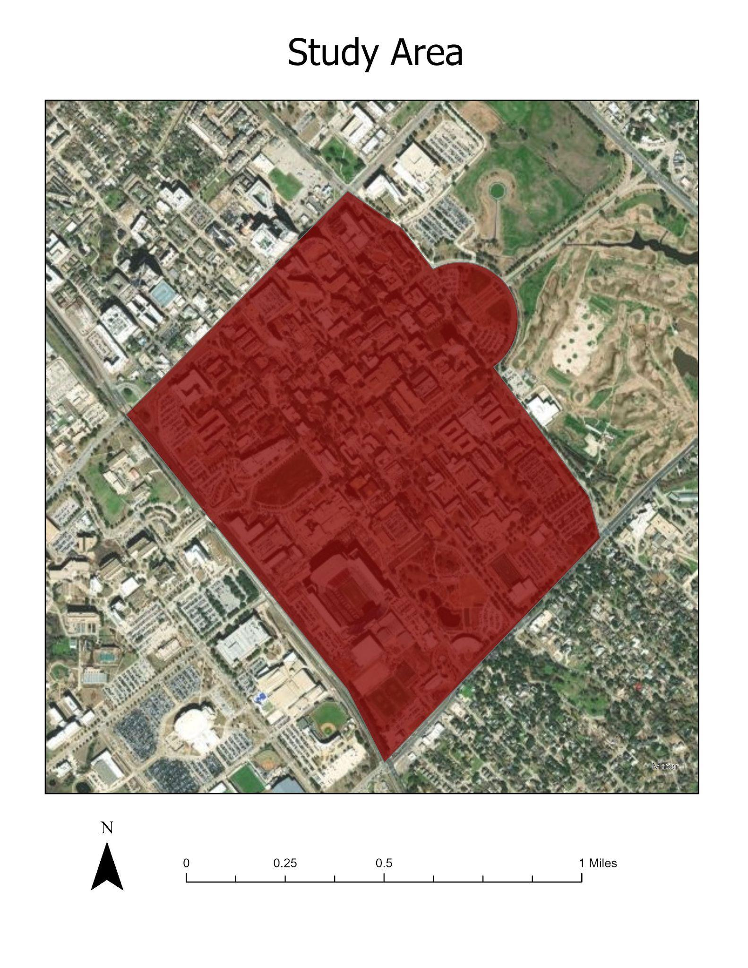

*Figure 1. Map of the study area where data was collected from Texas A&M University.*

Our team created our web map using ArcGIS Field Maps as our main application. This tool allowed us to simultaneously set points for the Blue Light Emergency Phones on campus (Figure 2). The data collection process was split between our team to effectively collect data points from campus (Figure 1). Each team member was assigned an area on campus, where they took a point, a picture, and the name of the nearest building for each emergency phone in the area. Mackenzie was responsible for collecting data near the Oceanography & Meteorology Building (OMB), Nichole collected near the Academic Plaza, Simpson Drill Field, and Memorial Student Center (MSC), Alex was in charge of collecting near Kyle Field and Aggie Park, Roberto and Destiny collected data from the Northside Dormitories. A total of 42 emergency phones were found around campus in this particular study area (Table 1). After the data for the Emergency Phones was collected and mapped, our team used a combination of HTML, CSS, and JavaScript to create a website. The website includes background information about the emergency phones, our study area, crime information on College Station, and a link to our interactive web map (Figure 3).

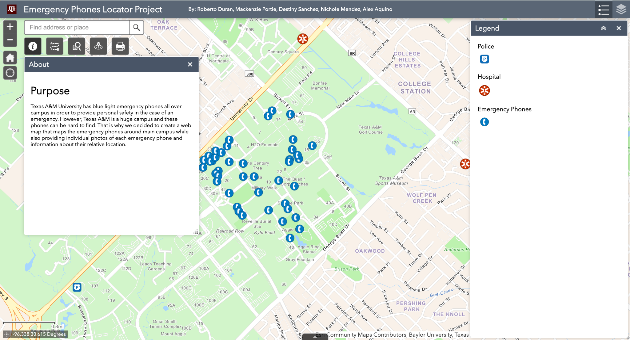

*Figure 2. Interactive web map our team created.*

| **Locations Near** | **Number of Emergency Phones** |
| --- | --- |
| Oceanography & Meteorology Building | 12 |
| Academic Plaza | 1 |
| Simpson Drill Field | 4 |
| Memorial Student Center | 3 |
| Kyle Field | 1 |
| Aggie Park | 5 |
| Northside Dormitories | 16 |
| **Total** | **42** |

*Table 1. The number of emergency phones across the Texas A&M University locations.*

Our website was designed to be user-friendly and interactive. Our team incorporated buttons, allowing users to navigate through the website easily (Figure 3). Accessibility features were also included in the design of the website by using a bigger font size and a “Go back to Menu” button for easier navigation. Our website also includes a button that takes you directly to our web map, where users can locate the nearest Emergency Phones, hospitals, or police stations that are near them. The user can also determine the distance between two locations through the button added to the map (Figure 2). Users can print our web map if they prefer a physical copy of these locations. The web map we created can also zoom in and out, an accessibility feature that can be useful for users (Figure 2).

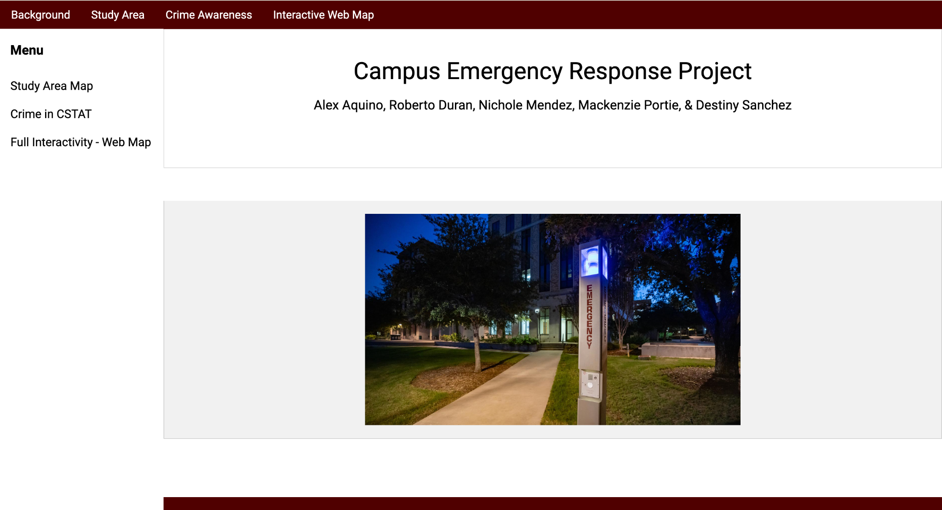

*Figure 3. Website our team created.*

**IV. Results**

The development and implementation of the website was focused on providing information about Blue Light Emergency Phones. We also created a web map, integrated into the website, that locates the emergency phones around the main campus and provides photos to easily identify each of the phones and information about its relative location (Nearest Building).

The website was created using HTML and JavaScript and the website contains multiple tabs that provide valuable information about our project (Figure 3). The background tab provides general information about our project such as how the locations were picked, why these emergency phones are placed on campus, and how they work. The study area tab provides a map of our study area where we collected our data (Figure 1). The crime awareness tab provides information about crime in College Station, Texas. The website also includes a tab for our web map that is embedded to it (Figure 2). It can also be viewed in a separate window if needed to.

The web map is fully functioning and has multiple features. The emergency phones are mapped with blue phone icons that are distinguishable; the Texas A&M University police are also mapped along with the nearby hospitals (Figure 2). We also added some other features to help users with navigating the map. There is a button that allows you to query features that are mapped (Figure 4). We also added a feature that allows users to get directions to any of the features on the map to help with navigation in case of emergency (Figure 5). For more accessibility, users are also able to print out the map in case they prefer a hard-copy version (Figure 6).

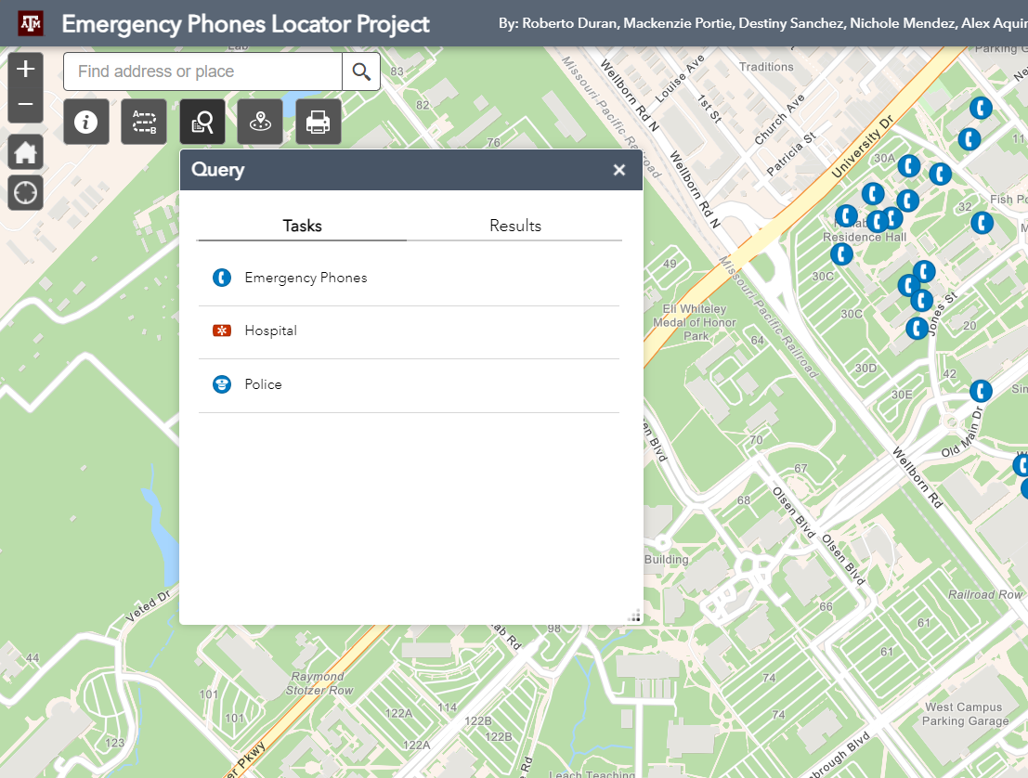

*Figure 4. Query Feature in our Web Map*

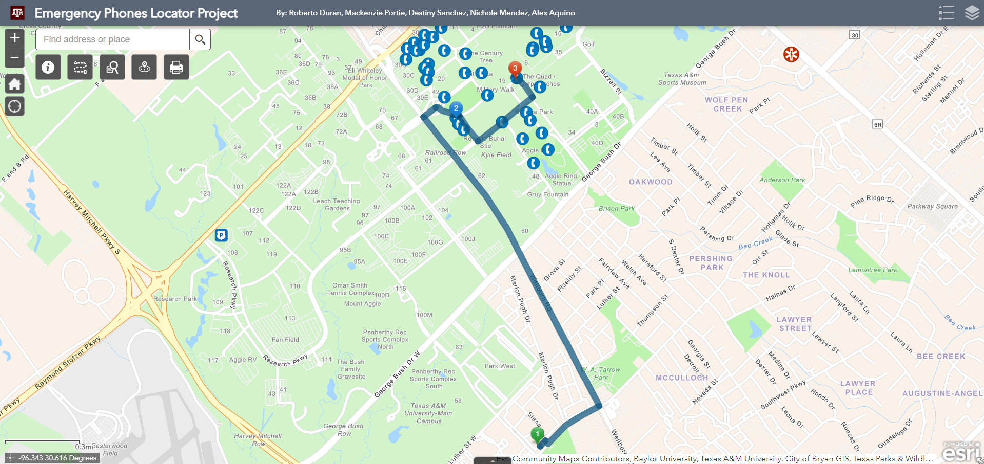

*Figure 5. Directions feature in our Web Map*

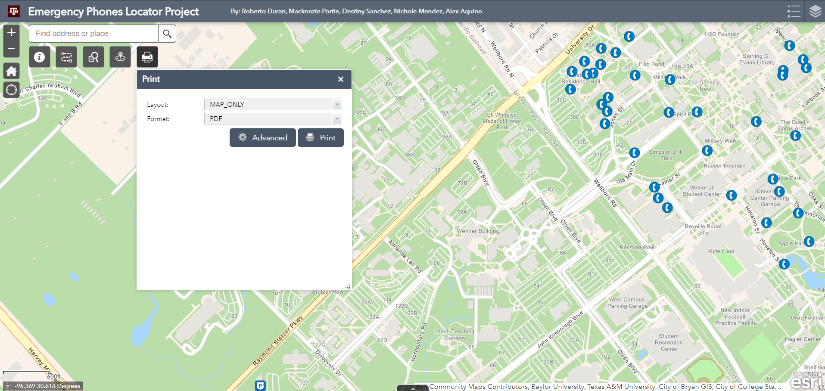

*Figure 6. Print feature in our Web Map*

The results of our study demonstrate successful implementation of a website that provides information about blue light emergency phones. Our dynamic web map also visualizes their location properly.

**IV. Discussion/Conclusion**

This study was limited to a 5:115 ratio of data collectors to Blue Light Emergency Phones. Given the time constraint of this study, we were also limited to what was physically accessible by foot, resulting in the exclusion of locations such as the Engineering Complex/Northside Recreation Center, the Corp/Southside dorms, and west campus. Our findings revealed a high concentration of Blue Light Emergency Phones around the residential halls but a notable lack of phones near Evans Library and the areas facing Northgate. It is our recommendation that these high trafficked areas should have emergency phone coverage or increased security to ensure quick access to emergency assistance and contribute to overall campus safety.

Ultimately, our project aimed to enhance campus safety and accessibility to emergency resources at TAMU's main campus. Through the creation of an interactive web map highlighting the locations of Blue Light Emergency Phones, hospitals, and police stations, our goal was to create a comprehensive tool for emergency preparedness. We hope that this information can serve as a valuable resource for the community to improve emergency response times, and improve overall safety on campus.

**V. References/Citations**

Ellcessor, Elizabeth. "Blue-light Emergency Phones on Campus: Media Infrastructures of Feeling." International Journal of Cultural Studies, vol. 22, no. 4, 2019, pp. 499-518. DOI: 10.1177/1367877918820336.